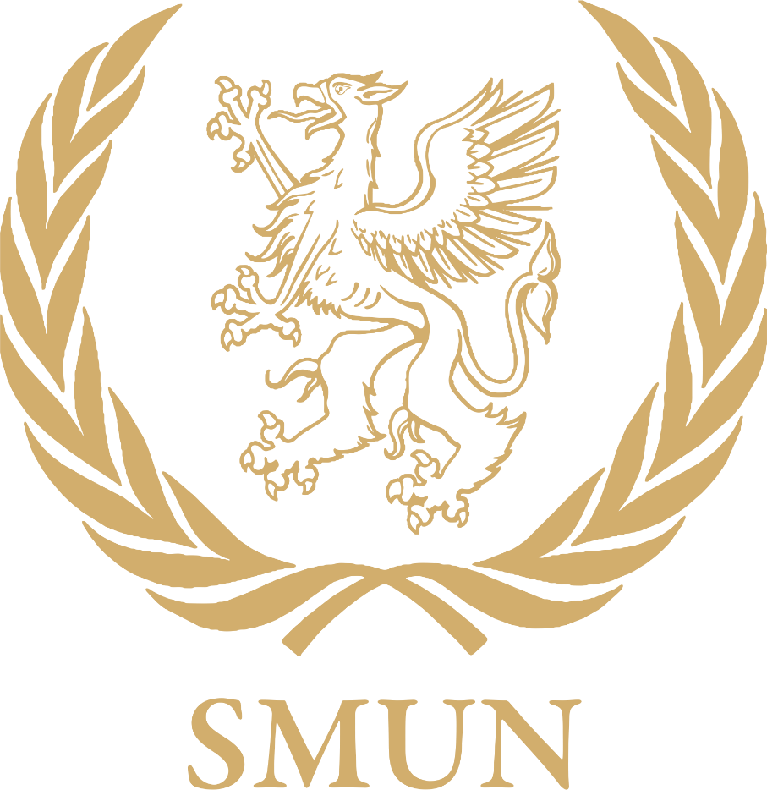

Nation Guide

Nation Guide (Checklist): Getting to know the basics of the country you represent

Official country name
Government system
Head of state
Official language(s)
Allies/blocs
Major religions
Major cities
Climate
Ports/waterways
Infrastructure status
Population
UN dues payment status
Environmental stance; e.g. problems, innovations
Standard of living /UNDP annual report)
Development status
UN Peacekeeping role (Blue Helmets)
Has the UN ever had to intervene in any conflict involving this nation?
If so, where and what were the circumstances?
Has the UN ever cited this country for Human Rights violations? If so, what were the circumstances?
What are the four problems/threats that currently seem to affect this nation?
Ethnic/ cultural issues
Refugee problems
Trade blocs/associations
Balance of payment/trade
Military organization
Military expenditure (% spent on defense)
Major weapons, arsenal, nuclear capabilities etc
% of GNP spent on Overseas Development Aid
Economic system
Major exports/imports
Major trade partners
IMF, WB, GATT positions (debtor or donor nation)
Agricultural products
Industries
National resources
Energy resources (type and origin)
Major conflicts past and present
Date admitted to the UN

Based on your research, what do you feel is at the heart of this nation’s identity?

Try to find at least one recent article that is about or makes reference to this nation (preferably from the last two weeks)

